NUCL 510 HMWK 2

1. Neutron Beam
   1. Beam Density

$$I=ρ_{beam}v_{beam}$$

$$ρ_{beam}=\frac{I}{v_{beam}}$$

$$I=5*{10}^{15}\frac{n}{cm^{2}s}$$

$$E=0.025 eV=4.01*{10}^{-14} erg$$

$$E=\frac{1}{2}mv_{beam}^{2}$$

$$v_{beam}=\sqrt{\frac{2E}{m}}=\sqrt{\frac{2\left(4.01*{10}^{-14} erg\right)}{\left(1.674927*{10}^{-24} g\right)}}=218821\frac{cm}{s}$$

(Wolfram Alpha LLC, 2011)

* 1. Atom Density of Li
 $$N_{Li}=\frac{N_{A}}{M_{Li}}ρ_{Li}$$

 $$N_{A}=6.022*{10}^{23}\frac{atoms}{mol}$$

$$M_{Li}=6.015122794\frac{g}{mol}$$

$$ρ_{Li}=0.535\frac{g}{cm^{3}}$$

$$N_{Li}=\frac{\left(6.022*{10}^{23}\frac{atoms}{mol}\right)}{\left(6.015122794\frac{g}{mol}\right)}\left(0.535\frac{g}{cm^{3}}\right)=5.356*{10}^{22}\frac{atoms}{cm^{3}}$$

$CITATION Wol11 \backslash l 1033$ $(Wolfram Alpha LLC, 2011)$

2. Tritium Production
 $$rxn rate= ϕ_{beam}*Σ_{rxn}=ϕ_{beam}*\left(σ_{rxn}*N_{Li}\right)$$

 $$ϕ_{beam}=I=5*{10}^{15}\frac{n}{cm^{2}s}$$

$$σ_{rxn}=945 barns=945*{10}^{-24} cm^{2}$$

$$N_{Li}=5.356*{10}^{22}\frac{atoms}{cm^{3}}$$

$$rxn rate=\left(5*{10}^{15}\frac{n}{cm^{2}s}\right)*\left(945*{10}^{-24} cm^{2}*5.356*{10}^{22}\frac{atoms}{cm^{3}}\right)=2.53071*{10}^{17}\frac{tritons}{cm^{3}s}$$

3. Maximum Tritium Activity

$$\frac{dN_{Li}}{dt}=-\frac{dT}{dt}$$

$$\frac{dN_{Li}}{dt}=N_{Li,0}e^{-σϕt}$$

$$\frac{dL}{dt}={σϕN}_{Li,0}e^{-σϕt}$$

$$\frac{dT}{dt}=\frac{dL}{dt}-\left(decay of Tritium\right)$$

$$\frac{dT}{dt}={σϕN}_{Li,0}e^{-σϕt}-(λT\left(t\right))$$

$$T\left(t\right)=c_{1}e^{-λt}+\frac{N_{Li,0}ϕσe^{-σϕt}}{λ-σϕ}$$

$$T\left(0\right)=0→0=c_{1}+\frac{N_{Li,0}ϕσ}{λ-σϕ}→c_{1}=-\frac{N_{Li,0}ϕσ}{λ-σϕ}$$

$$T\left(t\right)=-\frac{N_{Li,0}ϕσ}{λ-σϕ}e^{-λt}+\frac{N_{Li,0}ϕσe^{-σϕt}}{λ-σϕ}=\frac{N_{Li,0}ϕσ}{λ-σϕ}(e^{-σϕt}-e^{-λt})$$

max activity when T is maximum

$$N_{Li}=5.356*{10}^{22}\frac{atoms}{cm^{3}}$$

$$ϕ_{beam}=I=5*{10}^{15}\frac{n}{cm^{2}s}$$

$$σ_{rxn}=945 barns=945*{10}^{-24} cm^{2}$$

$$t_{\frac{1}{2}}=3.885*{10}^{8}s$$

$$λ=1.78416*{10}^{-9}s^{-1}$$

$$T_{maximum}=5.34*{10}^{22}tritons$$

$$V=cylinder which beam passes through=0.01 cm^{2}*0.005 cm=0.00005 cm^{3}$$

$$α_{maximum}=T*V*λ=5.34*{10}^{22}tritons*0.00005 cm^{3}*1.78416*{10}^{-9}s^{-1}=4.763*{10}^{9}Bq$$

1. Hydrogen Scattering

For angle between scattered neutron and recoil proton is 90o:

1. Differential Elastic Cross Section of Helium
   1. Elastic Cross Section
 $$σ_{s}\left(θ_{c}\right)=\frac{σ_{s}}{4π}\left(1+\cos\left(θ_{c}\right)\right)$$

 $$σ_{es}=\int_{0}^{2π}{\frac{σ_{s}}{4π}\left(1+\cos\left(θ_{c}\right)\right)dθ}=\frac{σ_{s}}{4π}\int_{0}^{2π}{\left(1+\cos\left(θ_{c}\right)\right)dθ}=\frac{σ_{s}}{4π}{\left[θ+\sin\left(θ\right)\right]}_{0}^{2π}=\frac{σ_{s}}{4π}2π=\frac{σ_{s}}{2}$$

 2. Fraction of neutrons at angles greater than 90o
   3. Differential Cross Section (COM and LS)

$$σ_{s}\left(E,μ_{s}\right)dμ_{s}=σ_{L}\left(E,μ_{L}\right)dμ_{L}$$

$$assuming σ_{s} is a constant, using value unity for σ_{s}$$

$$σ_{s}\left(θ_{c}\right)=\frac{σ_{s}}{4π}\left(1+\cos\left(θ_{c}\right)\right)$$

$$σ_{L}=σ_{s}(θ_{c})\frac{{\left(\frac{1}{A^{2}}+\frac{2}{A}\cos\left(θ_{c}\right)+1\right)}^{\frac{3}{2}}}{\frac{1}{A}\cos\left(θ_{c}\right)+1}$$

(Ragheb, 2006)

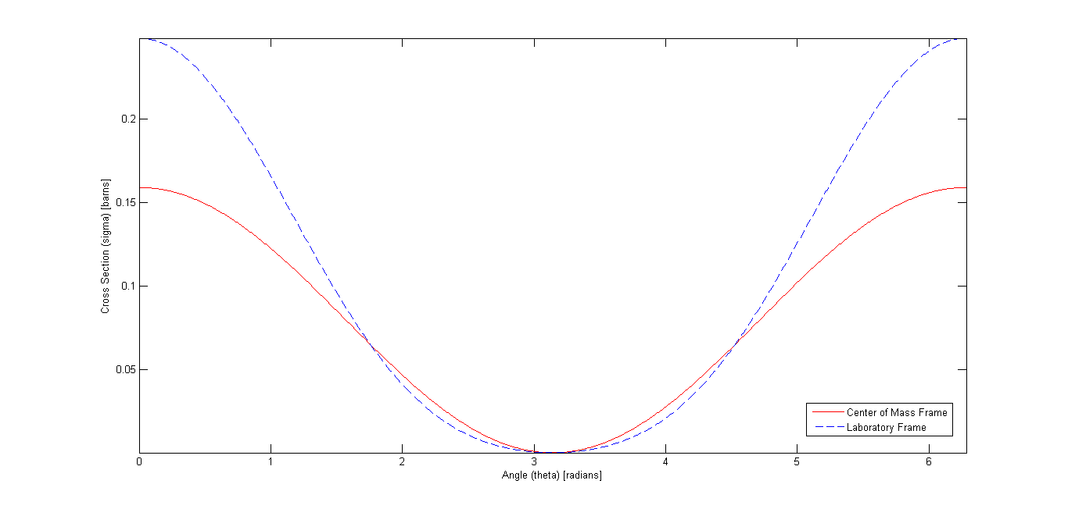

Figure 1 Cross Section in Laboratory and Center of Mass Frame

1. Maxwellian Monatomic Gas Model
   1. Doppler Broadened Cross Section

$$σ\left(v,T\right)=\frac{β^{\frac{1}{2}}}{\sqrt{π}v^{2}}σ_{s0}\int_{0}^{∞}{v_{r}^{2}}\left[e^{-β{\left(v-v_{r}\right)}^{2}}-e^{-β{\left(v+v_{r}\right)}^{2}}\right]dv_{r}=\left[\frac{β^{\frac{1}{2}}σ_{s0}}{v^{2}\sqrt{π}}\right]*\left\{\left[\frac{\sqrt{π}\left(2βv^{2}+1\right)\left(\operatorname{erf}\left(\sqrt{β}v\right)+1\right)}{4β^{\frac{3}{2}}}+\frac{ve^{-βv^{2}}}{2β}\right]+\left[\frac{ve^{-βv^{2}}}{2β}-\sqrt{π}\left(2βv^{2}+1\right)\left(1-\frac{\operatorname{erf}\left(\sqrt{β}v\right)}{4β^{\frac{3}{2}}}\right)\right]\right\}$$

$$σ\left(v,T\right)=\left[\frac{β^{\frac{1}{2}}σ_{s0}}{v^{2}\sqrt{π}}\right]*\left[\frac{\sqrt{π}\left(2βv^{2}+1\right)\left(2\operatorname{erf}\left(\sqrt{β}v\right)+1-4β^{\frac{3}{2}}\right)}{4β^{\frac{3}{2}}}+\frac{ve^{-βv^{2}}}{β}\right]$$

$$σ\left(v,T\right)=\frac{σ_{s0}\left(2βv^{2}+1\right)\operatorname{erf}\left(\sqrt{β}v\right)}{2βv^{2}}+\frac{σ_{s0}e^{-βv^{2}}}{βv^{\frac{1}{2}}\sqrt{π}}$$

(Wolfram Alpha LLC, 2011)

* 1. Scattering Cross Section Proportion
 $$σ\left(v,T\right)=\frac{σ_{s0}\left(2βv^{2}+1\right)\operatorname{erf}\left(\sqrt{β}v\right)}{2βv^{2}}+\frac{σ_{s0}e^{-βv^{2}}}{β^{\frac{1}{2}}v\sqrt{π}}$$

 $$\lim_{x→0}{\operatorname{erf}\left(x\right)=0}$$

$$\lim_{v→0}{σ(v,T)}=\frac{σ_{s0}\left(2βv^{2}+1\right)\operatorname{erf}\left(\sqrt{β}v\right)}{2βv^{2}}+\frac{σ_{s0}e^{-βv^{2}}}{βv^{\frac{1}{2}}\sqrt{π}}=\frac{σ_{s0}\left(2βv^{2}+1\right)*0}{2βv^{2}}+\frac{σ_{s0}}{β^{\frac{1}{2}}v\sqrt{π}}=\frac{σ_{s0}}{β^{\frac{1}{2}}\sqrt{π}}*\frac{1}{v}∝\frac{1}{v}$$

2. Scattering Cross Section at High Neutron Energy

$$\lim_{x→∞}{\operatorname{erf}\left(x\right)=1}$$

$$\lim_{v→∞}{σ(v,T)}=\frac{σ_{s0}\left(2βv^{2}+1\right)\operatorname{erf}\left(\sqrt{β}v\right)}{2βv^{2}}+\frac{σ_{s0}e^{-βv^{2}}}{βv^{\frac{1}{2}}\sqrt{π}}=\frac{σ_{s0}\left(2βv^{2}+1\right)*1}{2βv^{2}}+\frac{σ_{s0}*0}{β^{\frac{1}{2}}v\sqrt{π}}=\frac{σ_{s0}\left(2βv^{2}+1\right)}{2βv^{2}}=σ_{s0}+\frac{σ_{s0}}{2βv^{2}}=σ_{s0}$$